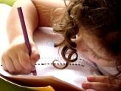  Literacy  In Literacy we will be following our Talk 4 Writing scheme. Our first unit involves a fiction journey tale about Little Red Riding Hood. We will then look at an instructional non-fiction text ‘How to trap a wolf’ in the second half of our half term. | 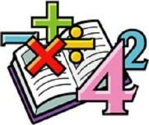  Maths  In Math, Year 2 will be learning about multiplication and division. This will include: equal and unequal groups, odd and even numbers, doubling and halving. |   Science  In Science, we will be learning about animals including humans. This will include the basic needs of humans such as exercise, hygiene and food. We will also start looking at the offspring of animals. |   Computing  This half term, we will be learning all about data handling. This will be linked to the international space station. We will be looking into how computers help humans in space, how sensors work, how to create an algorithm and interpreting data.
Humanities    In History, Year 2 will be looking at Neil Armstrong and why he is a significant individual. We will focus on timelines, space exploration and why people would want to go to space to explore. | Year 2 Curriculum Map  Overdale Community Primary School  Spring 1 term 2025  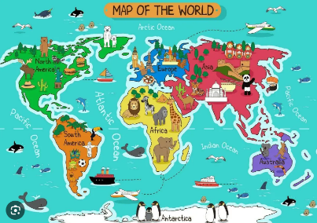  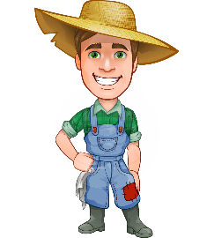 |  | 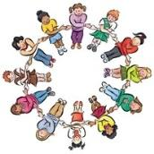  PHSCE In PHSCE and RSE we will continue developing our knowledge and skills surrounding citizenship, responsibility, community and democracy. This will include explaining why we have rules, the positives and negatives of the school environment and recognising the contribution people make to the community.
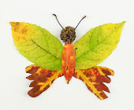  Art  In Art, Year 2 will be expressive painting. We will be develop a wide range of art and design techniques in using colour, pattern, texture, line, shape, form and space. | 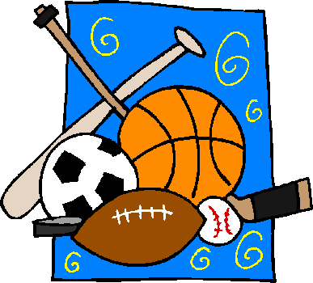  PE  In P.E, our focus will be dance. Throughout the half term, we will look at moving safely and in unison. Using different levels and direction while creating routines. | 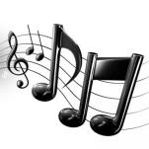  Music  In music we will explore using dot notation. They will be exploring pitch, how to maintain a steady beat and playing percussion instruments. |   RE  In RE we will be thinking about How and why do we celebrate special times’

